Established – 1961 Subject: internet of thinking
SEVA SADAN’S
















OF
ARTS, SCIENCE & COMMERCE ULHASNAGAR – 421 003


CERTIFICATE
This is to certify that Mr./Ms. _Shashikala gaud_
of S.Y. Computer Science (SYCS) Roll No. _2524021_ has satisfactorily completed The Internet Of Thing Mini Project entitled Smart medicine reminder system
during the academic year 2025 – 2026, as a part of the practical requirement. The project work is found to be satisfactory and is approved for submission.
PROF. INCHARGE HEAD OF DEPT

INDEX

Sr. No. | Chapters | Page No.
1 | Introduction | 3-7
2 | Requirement Specification | 8-9
3 | System Design | 10-17
4 | Implementation | 18-29
5 | System Testing and Result | 30-34
6 | Future Scope and Conclusion | 35-36
7 | References
8 | Glossary

INTRDUCTION

INTRODUCTION
The Smart Medicine Reminder System is an IoT-based healthcare project developed to help patients take their medicines on time. In today’s busy lifestyle, many people forget to take their prescribed medicines regularly. Missing medicines can lead to serious health problems, especially for elderly people and patients suffering from chronic diseases such as diabetes, blood pressure, and heart problems.
This system uses the ESP8266 WiFi module to send reminders directly to a smartphone. The system connects to WiFi and sends notifications at scheduled times. It is a simple, affordable, and efficient solution for medication management.
The project demonstrates how Internet of Things (IoT) technology can be used in healthcare applications to improve patient safety and daily routine management.
Motivation
In today’s busy lifestyle, many people forget to take medicines on time. This problem is common among elderly people, patients with long-term diseases, and people with hectic schedules. Missing medicine doses can cause serious health problems, slow recovery, and sometimes dangerous complications.
Most people depend on memory or family members to remind them, but this is not always reliable. Mobile alarms also fail because they can be ignored, muted, or forgotten.
Therefore, there is a need for a simple, automatic, and smart system that can remind patients at the correct time without human involvement.
The Smart Medicine Reminder System is motivated by the idea of using IoT technology (ESP8266 + Wi-Fi + Smartphone) to create a low-cost and easy-to-use reminder.
This system helps patients follow their prescription properly and improves health safety.
PROBLEM STATEMENT
In today’s fast-moving and busy lifestyle, many people forget to take their medicines at the correct time. This problem is more common among elderly people, working professionals, and patients suffering from chronic diseases such as diabetes, blood pressure, and heart problems. Missing even a single dose of medicine can negatively affect health and delay recovery.
The Smart Medicine Reminder System is developed to solve this issue by using IoT technology. It automatically sends notifications to the user’s smartphone at scheduled times, ensuring proper medication management and improving patient health safety.
HOW THE SYSTEM WORKS
The Smart Medicine Reminder System works using the ESP8266 WiFi module and internet connectivity to send medicine reminders directly to the user’s smartphone. The complete working process is explained below in a step-by-step manner:
First, the ESP8266 module is connected to a computer using a USB cable. The program code is written in Arduino IDE software. In this code, the WiFi network name (SSID), password, and medicine reminder time are entered. The scheduled time is set according to the user's requirement, such as morning, afternoon, or night.
After writing the program, the code is uploaded into the ESP8266 module. Once uploaded, the ESP8266 automatically connects to the WiFi network using the stored credentials.
The ESP8266 continuously checks the current time and compares it with the scheduled medicine time set in the program. When the current time matches the scheduled time, the ESP8266 sends a notification signal through the internet.
This notification is received on the user’s smartphone in the form of an alert message. The message reminds the user to take the specific medicine at that time.The system works automatically once powered on and connected to WiFi. No manual operation is required after setup. This ensures that the user receives medicine reminders regularly and on time
KEY FEATURES
Sends medicine reminders on time
Uses ESP8266 WiFi module
Connects to internet through WiFi
Sends notification to smartphone
Easy to set up and use
Automatic working system
Low cost and affordable
Helps elderly and patients
Reduces chances of missing medicine
Simple and reliable design
SCOPE OF THE PROJECT
The Smart Medicine Reminder System has wide scope in the healthcare field. This project can be used in homes, hospitals, and old age homes to help patients take medicines on time. It is especially useful for elderly people and patients who need regular medication.The system can be expanded by adding more advanced features such as multiple medicine scheduling, buzzer alarm, LCD display, automatic medicine dispensing box, and mobile application interface. Cloud storage can also be added to maintain medicine history and health records.
In the future, this project can be integrated with Artificial Intelligence and health monitoring sensors to create a complete smart healthcare system. It has the potential to improve patient safety and reduce medical emergencies caused by missed doses.
OBJECTIVES OF THE PROJECT
The main objectives of the Smart Medicine Reminder System are:
To develop a smart medicine reminder using ESP8266 WiFi module.
To send notifications to the user’s smartphone at scheduled times.
To ensure timely medicine intake and reduce missed doses.
To use IoT technology in the healthcare sector.
To design a simple, low-cost, and user-friendly system.
To reduce dependency on family members for reminders.
To improve patient health management and safety.
To demonstrate practical implementation of embedded systems and WiFi communication.
KEY GOALS OF THE PROJECT
To create a reliable medicine reminder system.
To ensure patients take medicines on time without fail.
To provide real-time notification on a smartphone.
To make the system simple and easy to use.
To design a low-cost healthcare solution using ESP8266.
To improve medication management for elderly and busy individuals.
To demonstrate the use of IoT in daily healthcare applications.
To reduce health risks caused by missed medicine doses.

REQUIREMENT SPECIFICATION

Hardware Requirement

Sr. No. | Component Name | Quantity | Description
1 | ESP8266 Wi-Fi Module (NodeMCU) | 1 | Main microcontroller used to control the system and connect with Wi-Fi
2 | USB Cable | 1 | Used to upload program and provide power supply to ESP8266
3 | Computer / Laptop | 1 | Used for coding, uploading program and monitoring data
4 | Smartphone | 1 | Used to receive medicine reminder notifications
5 | Wi-Fi Connection | 1 | Provides internet connection between ESP8266 and smartphone

Software Requirement
Sr. No. | Software Name | Purpose
1 | Arduino IDE | To write, compile and upload the program into ESP8266
2 | Embedded C / Arduino Programming | Used to develop the logic of medicine reminder system
3 | Blynk / IoT Mobile App | To send medicine reminder notification to smartphone
4 | Wi-Fi Network | To connect ESP8266 with mobile application through internet
5 | Operating System (Windows / Android) | To run Arduino IDE on computer and mobile application on smartphone

Software Library
Sr. No. | Library Name | Purpose
1 | ESP8266WiFi.h | To connect ESP8266 module with Wi-Fi network
2 | BlynkSimpleEsp8266.h | To communicate ESP8266 with Blynk mobile application
3 | TimeLib.h | To manage time and schedule medicine reminder
4 | WidgetRTC.h | To get real time clock from internet server
5 | Arduino.h | Basic functions for program execution and device control

SYSTEM DESIGN

Block Diagram
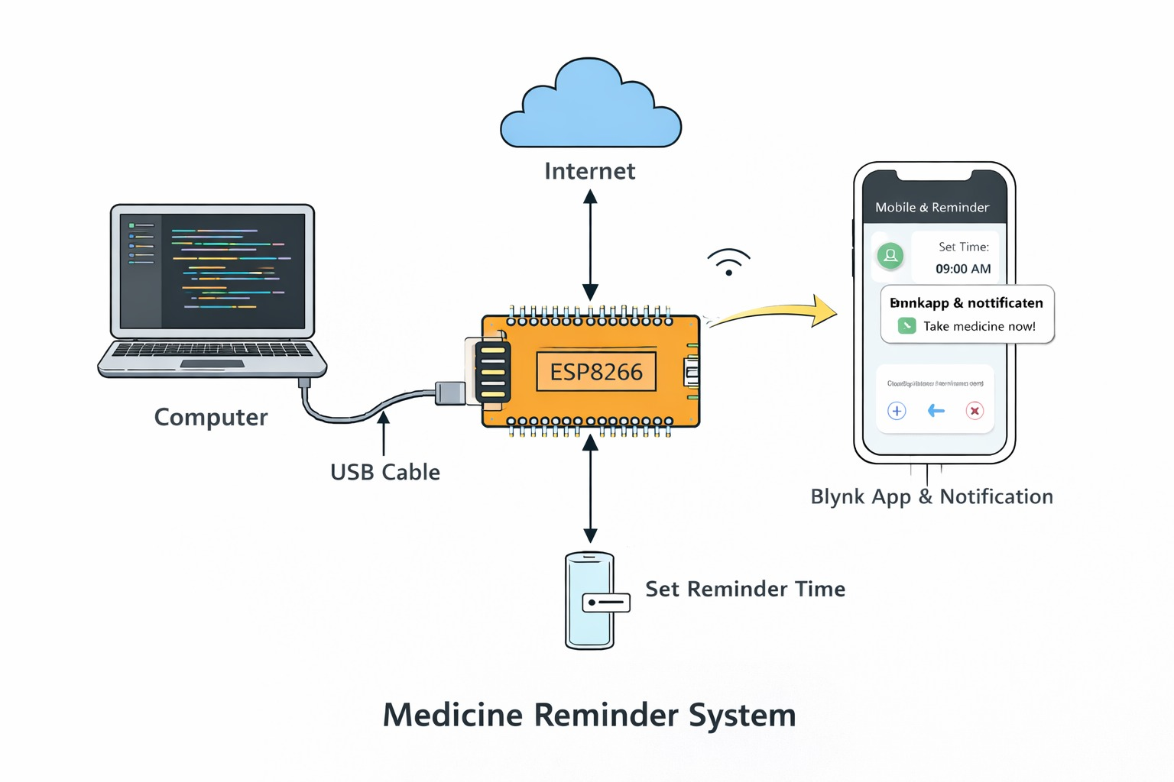

Block Diagram Explanation:
The ESP8266 connects to the Wi-Fi network and communicates with the smartphone application.
The user sets medicine time in the mobile app, and at the scheduled time the system sends a reminder notification to the user.

Circuit Diagram
uses only ESP8266 + USB + Wi-Fi (no sensors), the circuit is very simple.
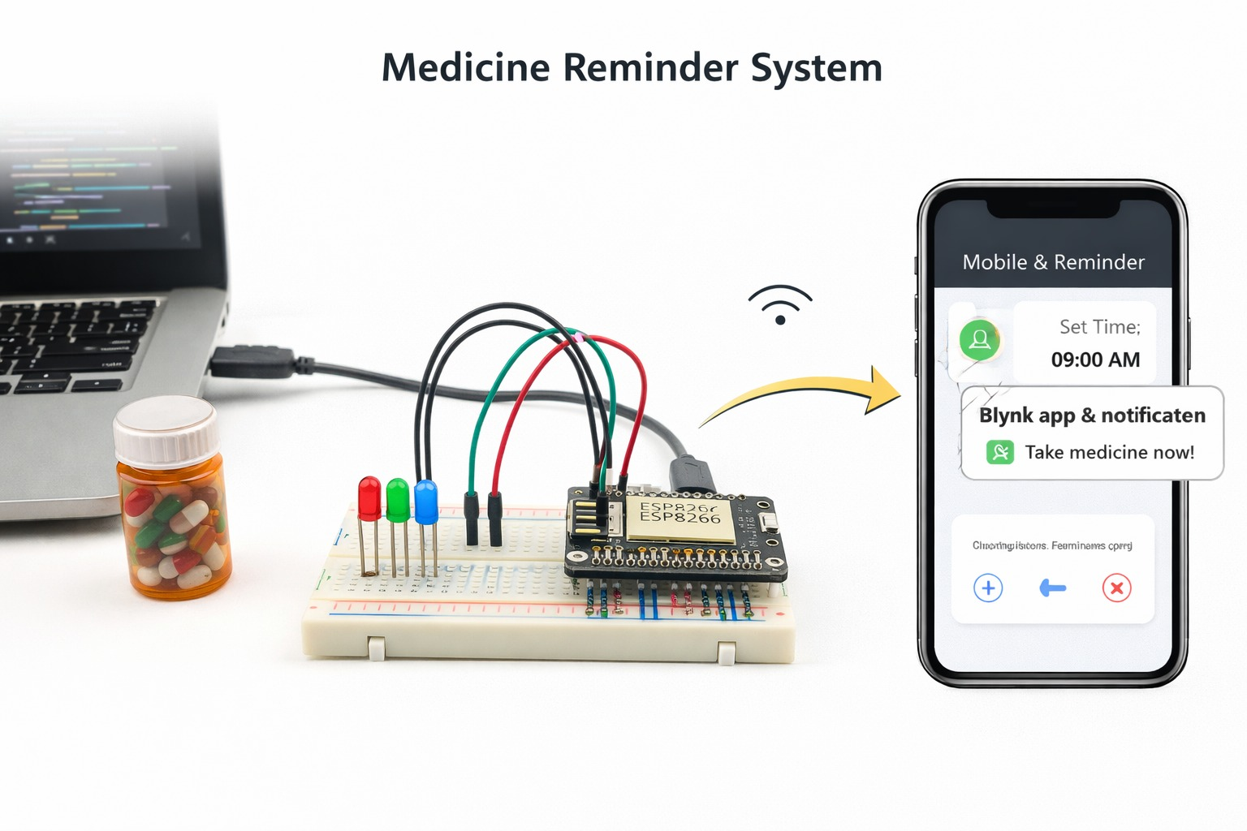
- Circuit Diagram Explanation:
Connect the NodeMCU (ESP8266) to the computer using a USB cable.
- The USB cable provides power supply and also helps to upload the program into the ESP8266.
- After uploading the code, the ESP8266 automatically turns ON.
- The ESP8266 connects to the Wi-Fi network using stored SSID and password.
- The ESP8266 establishes communication with the mobile application (Blynk) through the internet.
- The user sets medicine reminder time in the mobile app.
- The real-time clock (RTC from internet) checks the current time continuously.
- When the set time matches, the ESP8266 sends a notification reminder to the smartphone.
- The user receives the alert and takes medicine on time.

Benefits of Circuit Diagram
- Helps to understand how all components are connected in the system.
- Makes the working of the project easy to explain and visualize.
- Reduces wiring mistakes during implementation.
- Helps in troubleshooting and repairing the system.
- Saves time while assembling the hardware.
- Useful for documentation and future reference.
- Makes the project easier for others to reproduce.
- Clearly shows power supply and communication connections.
When to Use a Circuit Diagram
- Before starting hardware assembly of the project.
- While connecting electronic components together.
- During testing and debugging of the system.
- To explain the project in viva or presentation.
- When repairing or modifying the circuit.
- For documentation in project reports or journals.
- When other users need to understand or reproduce the project.
- To verify power supply and connections before powering ON.

Circuit Model Testing Methods
- Power Supply Testing
Check whether the NodeMCU (ESP8266) turns ON properly after connecting the USB cable.
- Wi-Fi Connectivity Test
Verify that ESP8266 successfully connects to the Wi-Fi network (SSID & Password).
- Code Upload Test
Upload the program from Arduino IDE and confirm there are no compilation or upload errors.
- Server / App Connection Test
Check whether the ESP8266 connects to the mobile application (Blynk).
- Time Synchronization Test
Verify that the system receives correct real time clock (RTC) from the internet.
- Reminder Trigger Test
Set a test medicine time and confirm the notification is sent at the correct time.
- Notification Verification Test
Ensure the smartphone receives alert message properly.
- Continuous Running Test
Run the system for long duration to confirm stable operation without disconnection.
Use Case Diagram
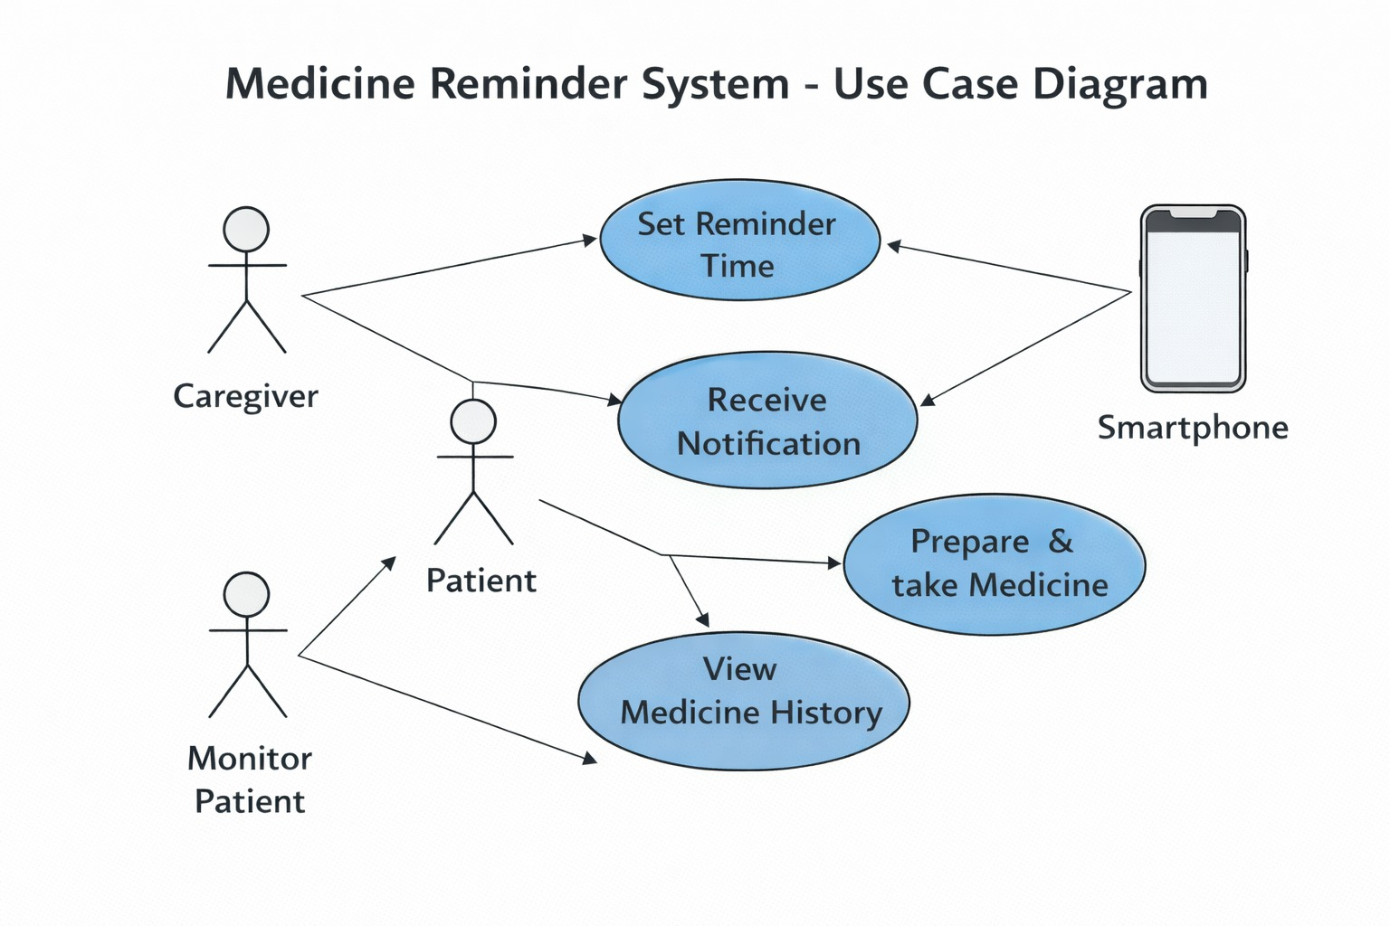
Use Case Diagram Explanation
The User interacts with the Smart Medicine Reminder System through the mobile application.
The user can:
- Set medicine time
- Edit or delete schedule
- View saved reminders
- Receive reminder notifications
The system:
- Connects to Wi-Fi
- Checks time continuously
- Sends notification at scheduled time

Activity Diagram

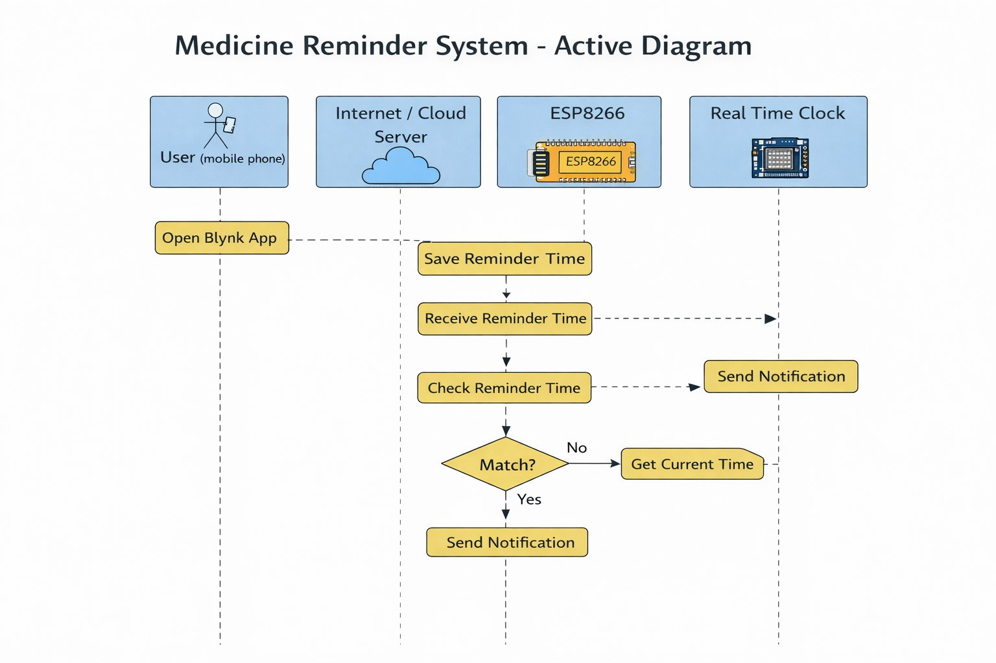

Activity Diagram Explanation
- System starts when ESP8266 is powered ON.
- It connects to Wi-Fi network.
- The system gets real time from internet server.
- User sets medicine reminder time from mobile app.
- The system continuously compares current time with set time.
- When time matches, notification is sent to smartphone.
- User receives alert and takes medicine.

Class Diagram
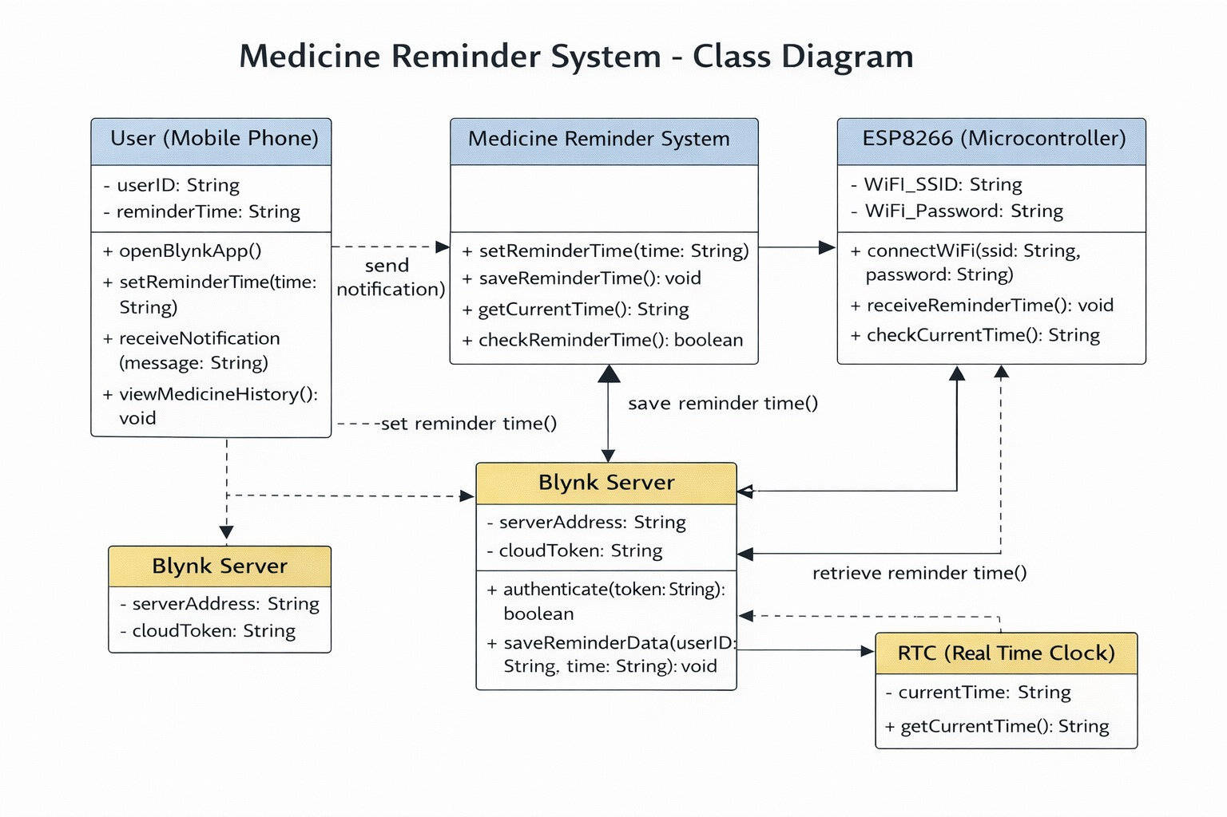
Class Diagram Explanation
- The diagram shows classes: User, Medicine Reminder System, ESP8266, Blynk Server, and RTC.
- Attributes: Store data like userID, reminderTime, WiFi credentials, etc.
- Methods: Perform actions like setReminderTime(), checkTime(), sendNotification(), connectWiFi().
- Relationships:
  - User sets reminder → interacts with Medicine Reminder System.
  - Reminder system communicates with ESP8266 → gets time from RTC → sends notifications through Blynk Server.

Advantages of gantt chart
- Clear visual schedule
Shows the whole project timeline in one view — you can easily see what happens when.
- Easy task planning
Helps you break a big project into small tasks and arrange them step-by-step.
- Tracks progress
You can quickly compare planned vs actual work and know if you are behind or ahead.
- Better time management
Helps set start date and end date for every activity, so deadlines are clear.
- Shows task dependency
You can understand which task must finish before the next one starts.
- Improves teamwork
Everyone knows their responsibility and when to complete it.
- Reduces confusion
Avoids overlapping work and missed tasks.
- Helps in presentation
Very useful for explaining your project plan to teacher, guide, or team.

SYSTEM IMPLEMENTATION

Components & Assembling
Components Used

Step 1:
Firstly, identify these components

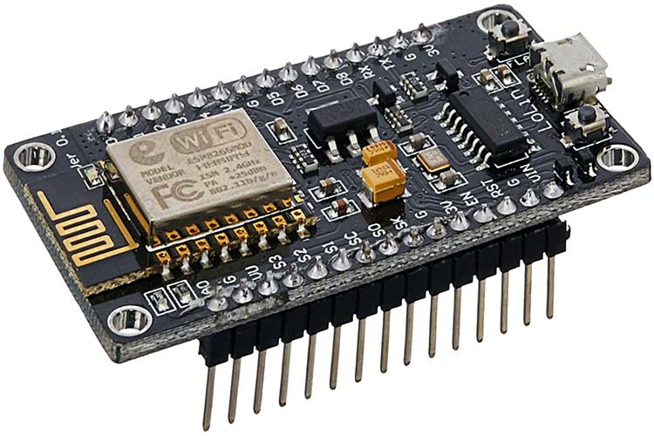

USB CABEL
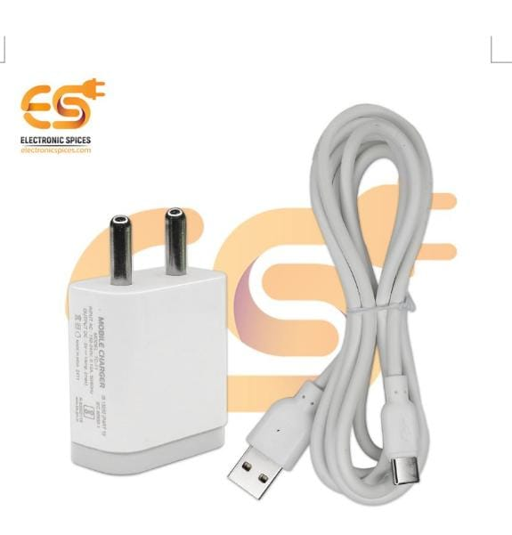

Step 2:
checking connection

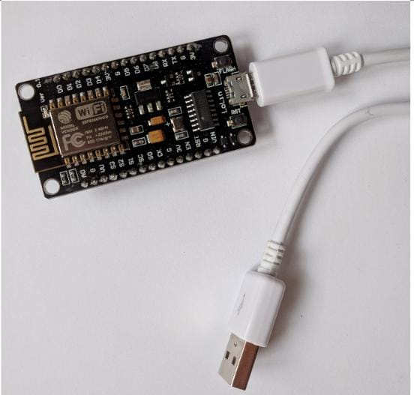

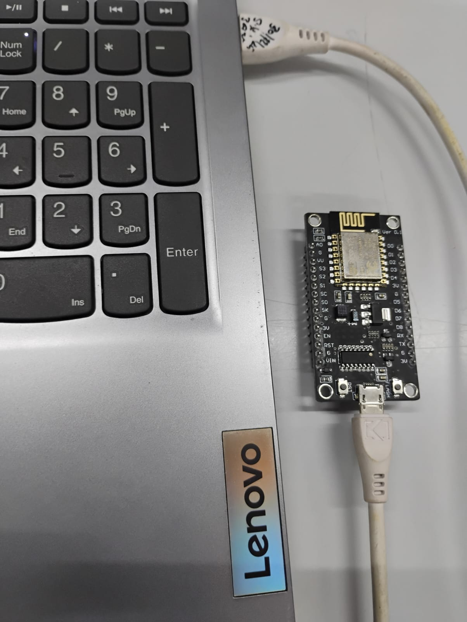

Step 3:
So, let’s create the program for this project. .It is as follows.
#define BLYNK_TEMPLATE_ID "TMPL3H5OGT3wh"
#define BLYNK_TEMPLATE_NAME "Medicine Reminder"
#define BLYNK_AUTH_TOKEN "Iy1wVFRX4FBEF7tvoqqD09QvKRsOQoCS"

#define BLYNK_PRINT Serial
#include <ESP8266WiFi.h>
#include <BlynkSimpleEsp8266.h>
#include <TimeLib.h>
#include <WidgetRTC.h>

char ssid[] = "Ragini";
char pass[] = "12345678";

WidgetRTC rtc;
BlynkTimer timer;

int reminderHour = -1;
int reminderMinute = -1;
bool notified = false;

BLYNK_WRITE(V1)
{
TimeInputParam t(param);

if (t.hasStartTime())
{
reminderHour = t.getStartHour();
reminderMinute = t.getStartMinute();

Serial.print("Reminder Time Set: ");
Serial.print(reminderHour);
Serial.print(":");
Serial.println(reminderMinute);

notified = false; // reset notification flag
}
}

void checkTime()
{
if (reminderHour == -1) return; // time not set

Serial.print("Current Time: ");
Serial.print(hour());
Serial.print(":");
Serial.println(minute());

if (hour() == reminderHour && minute() == reminderMinute && !notified)
{
Serial.println("Medicine Time!");
Blynk.logEvent("medicine_alert", "Take medicine now");
notified = true; // prevent repeat
}

if (minute() != reminderMinute)
{
notified = false; // reset after minute passes
}
}

void setup()
{
Serial.begin(9600);
Blynk.begin(BLYNK_AUTH_TOKEN, ssid, pass);
rtc.begin();
Blynk.syncVirtual(V1); // VERY IMPORTANT
timer.setInterval(30000L, checkTime); // check every 30 sec
}

void loop()
{
Blynk.run();
timer.run();
}

Step 4: code explation
#define BLYNK_TEMPLATE_ID "TMPL3H5OGT3wh"
#define BLYNK_TEMPLATE_NAME "Medicine Reminder"
#define BLYNK_AUTH_TOKEN "Iy1wVFRX4FBEF7tvoqqD09QvKRsOQoCS"
These connect your ESP8266 to the Blynk cloud.
Think of this as your project’s ID card.
#define BLYNK_PRINT Serial
#include <ESP8266WiFi.h>
#include <BlynkSimpleEsp8266.h>
#include <TimeLib.h>
#include <WidgetRTC.h>
Libraries used:
- ESP8266WiFi → connects to WiFi
- BlynkSimpleEsp8266 → connects to Blynk mobile app
- TimeLib → handles time (hour, minute)
- WidgetRTC → gets real time from internet

2. WiFi Details
char ssid[] = "Ragini";
char pass[] = "12345678";
Your ESP8266 connects to this WiFi network to access internet.

3. Objects Creation
WidgetRTC rtc;
BlynkTimer timer;
- rtc → gets real time clock from internet
- timer → runs a function repeatedly after some time

4. Variables (Store Reminder Time)
int reminderHour = -1;
int reminderMinute = -1;
bool notified = false;
- reminderHour → medicine hour
- reminderMinute → medicine minute
- notified → prevents repeating notification

5. Setting Time from Mobile App
BLYNK_WRITE(V1)
When you select time in Blynk Time Input widget:
TimeInputParam t(param);
Reads the time from mobile app.
reminderHour = t.getStartHour();
reminderMinute = t.getStartMinute();
Stores the selected time.
notified = false;
Allows notification again for next day.
👉 So:
User sets medicine time in phone → ESP8266 saves it

6. Checking Current Time
void checkTime()
This function runs every 30 seconds.
Step 1: Ignore if time not set
if (reminderHour == -1) return;

Compare current time with reminder time
if (hour() == reminderHour && minute() == reminderMinute && !notified)
If both times match:
Blynk.logEvent("medicine_alert", "Take medicine now");
📱 Mobile notification is sent
Then:
notified = true;
Prevents sending notification again in same minute.

Step 3: Reset next minute
if (minute() != reminderMinute)
{
notified = false;
}
Allows next day reminder again.

7. Setup Function (Runs Once)
void setup()
- Start serial monitor
- Connect to WiFi + Blynk
- Start internet clock
- Sync time from app
- Check time every 30 sec
timer.setInterval(30000L, checkTime);

8. Loop Function (Runs Forever)
void loop()
{
Blynk.run();
timer.run();
}

- Keeps Blynk connected
- Keeps checking reminder time

Final Working (Very Simple Flow)
- User sets medicine time in mobile app
- ESP8266 gets real time from internet
- Every 30 seconds it checks time
- If time matches → notification sent
- Notification only once per minute

SYSTEM TESTING And RESUlT

Step 5:
Setup in bylnk:
STEP 1 — Create Template
- Open bylnk
- Create Template
- Get Auth Token
- Create datastream
- Create device
- Web dashboard /mobile dashboard
- Add code in Arduino
- Test

Create template:
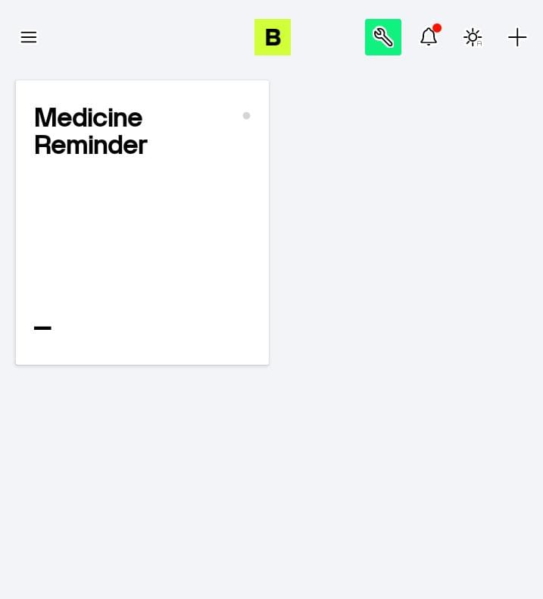

Add time:

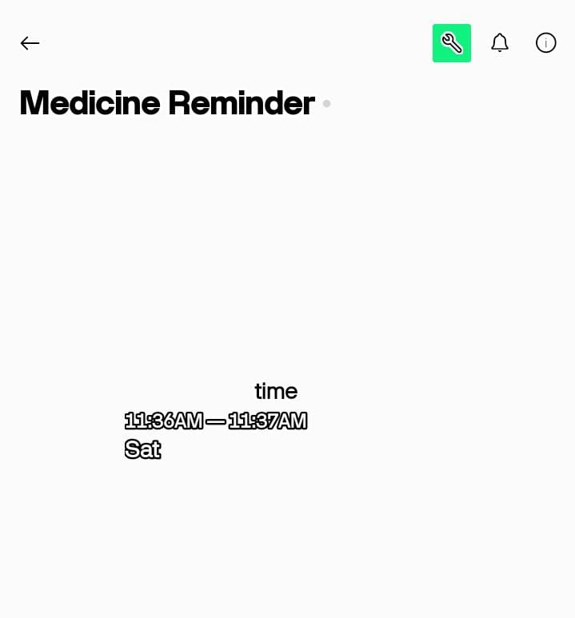

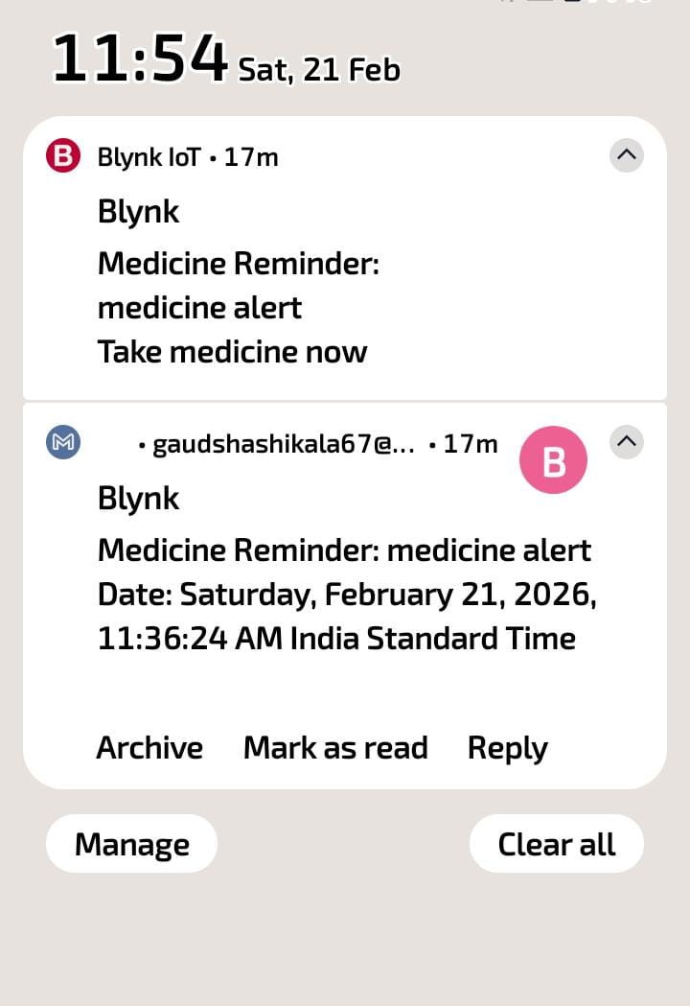

FUTURE SCOPE AND CONCLUSION

Future Scope of Smart Medicine Reminder System
- Multiple Medicine Scheduling
Allow setting reminders for many medicines at different times.
- Automatic Medicine Box
IoT-enabled box opens automatically at the correct time.
- Caregiver Alerts
Notify family or caregivers if medicine is missed.
- SMS Alert (No Internet Needed)
Using GSM module, reminders can work without WiFi.
- Voice Assistant Integration
System can speak: “Time to take your medicine.”
- Health Monitoring Sensors
Add heart rate, BP, or temperature sensors for elderly patients.
- Mobile App History
Keep a log of taken and missed medicines.
- AI Smart Reminders
Suggest best medicine times based on user habits.

Conclusion of Smart Medicine Reminder System
The Smart Medicine Reminder System is a simple, low-cost, and effective IoT project using ESP8266 and the Blynk app. It allows users to set medicine times on their mobile phone, and automatically sends notifications when it’s time to take the medicine.
This system helps patients, especially the elderly, to take medicines on time, reduces human error, and improves medication adherence. It is portable, easy to use, and can be upgraded in the future with advanced features like multiple reminders, caregiver alerts, and health monitoring.

References
- Blynk IoT Official Documentation – https://docs.blynk.io/
- ESP8266 Wi-Fi Module Datasheet – https://www.espressif.com/en/products/socs/esp8266
- Arduino Official Website – https://www.arduino.cc/reference/en/
- Time Library (TimeLib.h) Documentation – https://www.pjrc.com/teensy/td_libs_Time.html
- Research Papers on IoT-Based Medicine Reminder Systems
  - International Journal of Scientific Research in Computer Science, Engineering & IT
  - IEEE Xplore Digital Library
- YouTube Tutorials (ESP8266 + Blynk Projects)
  - Tech StudyCell
- Electronics Innovation

Glossary (Detailed)
Term | Meaning | Explanation / Context in Project
IoT (Internet of Things) | A system where devices are connected to the internet and communicate with each other. | In this project, ESP8266 connects to the internet to receive and send reminder notifications via the Blynk app.
ESP8266 | A low-cost Wi-Fi microcontroller. | Acts as the brain of the project, controlling the reminder system, checking time, and sending notifications to the mobile app.
Blynk App | A mobile application to control and monitor IoT devices. | Users set medicine reminder time on the app; notifications are sent through this app.
Real-Time Clock (RTC) | A clock that keeps track of the current time even when the system is powered off. | The system uses the internet RTC to compare the current time with the reminder time.
Notification | An alert sent to the user’s device. | In this project, it reminds the user to take the medicine at the scheduled time.
Wi-Fi Module | Hardware that allows a device to connect to the wireless internet. | ESP8266 itself acts as a Wi-Fi module connecting the device to Blynk server.
Microcontroller | A small computer on a single integrated circuit. | ESP8266 microcontroller processes data, checks time, and communicates with the mobile app.
Virtual Pin | Software pin in Blynk used to send/receive data between app and hardware. | V1 is used to input and sync reminder time from the Blynk app to ESP8266.
Timer | A function that triggers actions at specific intervals. | Checks the current time every 30 seconds to see if it matches the reminder time.
Cloud Server | Online server where the app and device communicate. | Blynk cloud server stores data and helps send notifications from ESP8266 to the mobile app.
Automation | Performing tasks automatically without human intervention. | The system automatically checks time and sends reminders without the user needing to manually monitor it.
Reminder | An alert set to occur at a specific time. | User sets the reminder time in the Blynk app; ESP8266 sends notification when that time comes.
Embedded System | A system combining hardware and software for a specific task. | The ESP8266 with the uploaded program forms an embedded system for the medicine reminder.

